Bonecas Russas Edits

- M6 -9, Bcl: see edits to manuscript and update current version. They are 1) I added tons of dynamics; M9 I added triplet rest before fermata and beat 1 dynamics.

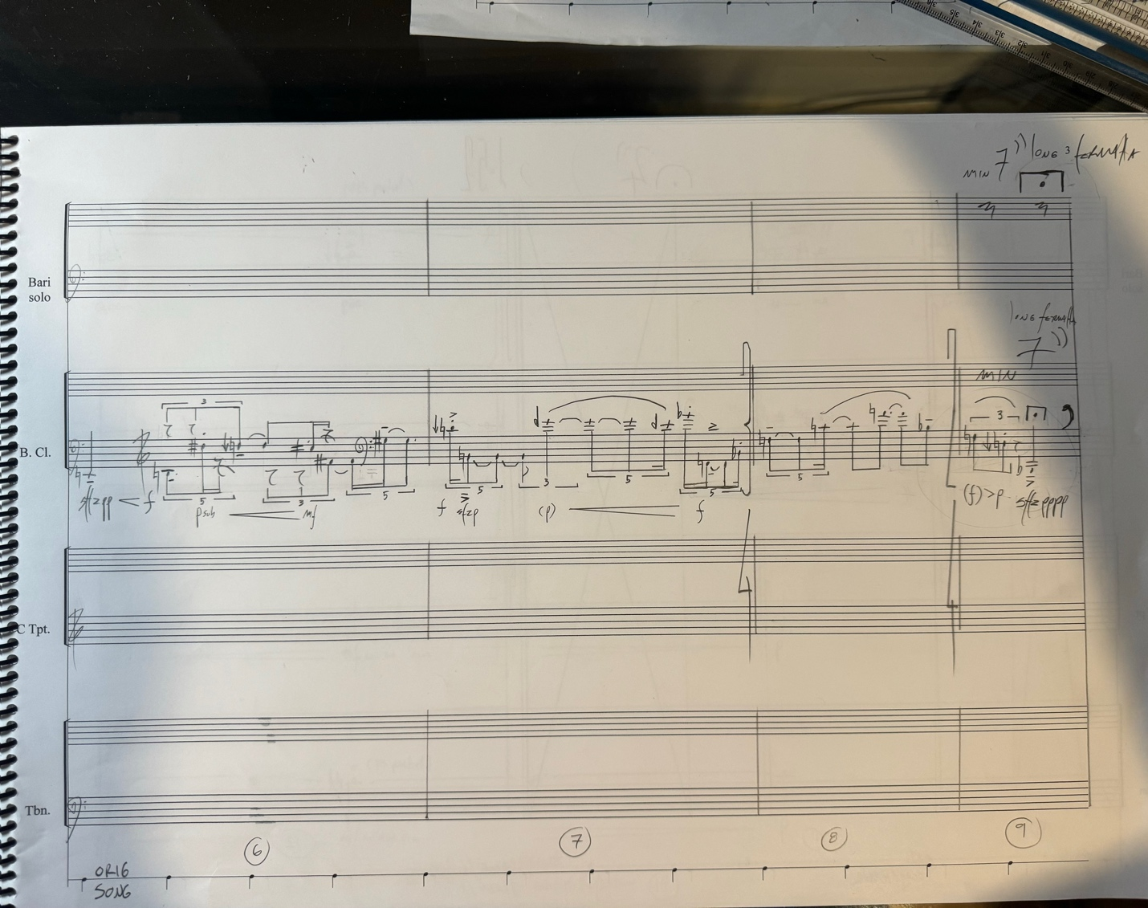

- M11, add “ 4’ ” next to fermata in the end of the bar (score and parts)
- M12, change tempo to quarter = 52
- M15, voice: beat 1 add diminuendo between 1st and second notes, to pp; then back to mp on beat 4
- M17, voice: add diminuendo to p from first to 2nd note, (mf>p), then leave p<f in the second half of the measure; for Bcl, add diminuendo to p from first quartermjote to 2nd then add (p) and cresc to mf on first beat of M18.

- M20, voice: change the rhythm of text and actual rhythm according to picture below:
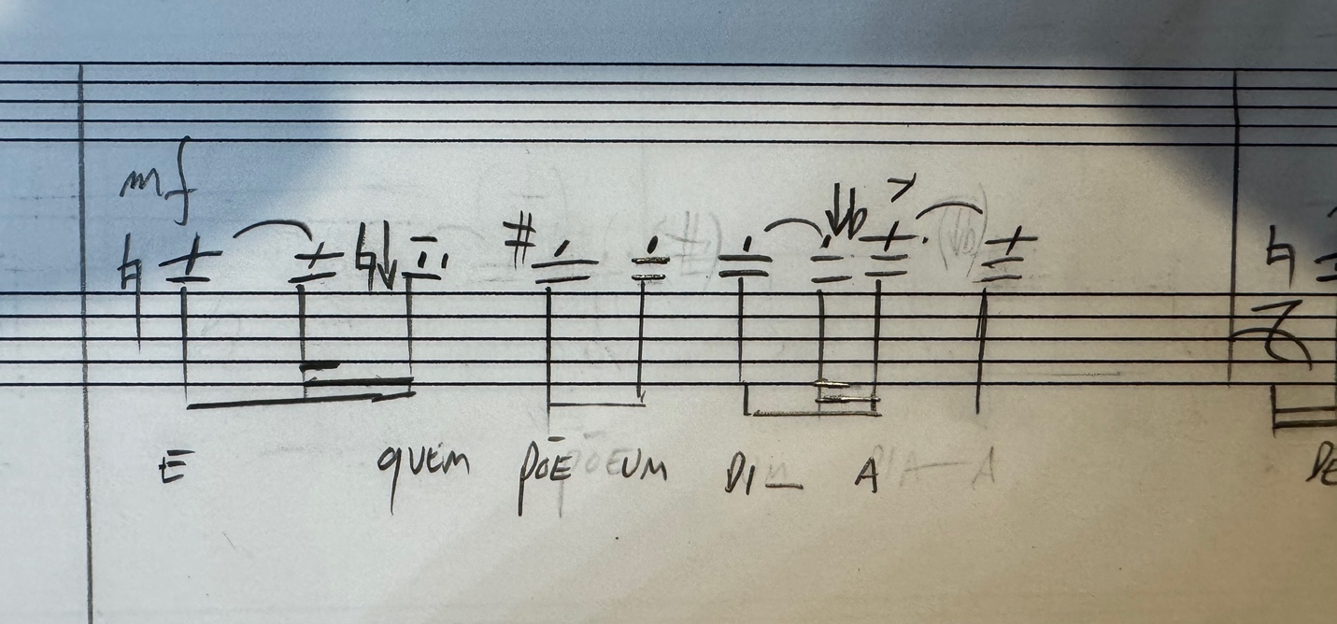

- M60, voice, beat 3: connect first and second G# with a tie

- M67, voice: add another quarter note F on beat 3 and a quarter rest on beat 4, then add “(mf) on beat 2 and diminuendo to pp right before beat 4.

- M68, voice: add mf-f (shape freely)

- M73, voice: move text “i-“ to F attack on beat 3, and move slur to start from same note as new text placement

- M75, voice: add “(mf) of beat 2 and diminuendo to ppp right before beat 4. Them replace M76 downbeat with “(ppp)”

- M112, voice: add “(mf)” on beat 1 and diminuendo to ppp right before beat 4. Then add “f” on beat 1of M113

- M113, voice: beat 3, make quintuplet 8th rest into B tied from note before, so that there are no rests before last quintuplet 16th

- M127, voice: beat 3, add “(mf)”

- M128, voice: add “mf > ppp” from beat 2 to before beat 4 Then add “mf” on M129 first note

- M130, voice: add “(mf) > ppp” from beat 2 to end of bar

